EXERCISE 2
1. Write the SELECT statement to extract the IDs of employees who are more than 30 years of age.
SELECT employee_id FROM employee_data WHERE age > 30;
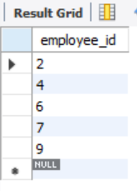

2. Write the SELECT statement to extract the first and last names of all web designers.
SELECT f_name, l_name FROM employee_data WHERE title = 'Web Designer';
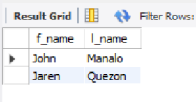

3. What will the following SELECT statement display: SELECT * FROM employee_data WHERE salary <= 1000000?
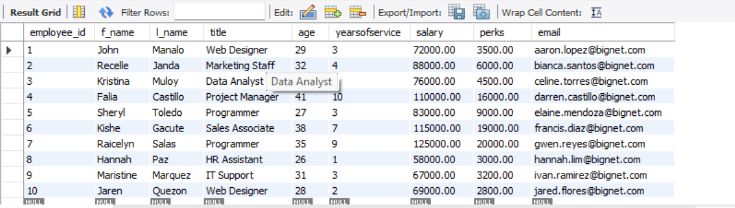
All column will display from table employee_data whose salary is less than equal to 1,000,000
4. How will you display the salaries and perks for employees who have more than $16,000 as perks?
SELECT salary, perks FROM employee_data WHERE perks > 16000;
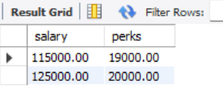

5. List all employee names (last name followed by first name) who hold the title of Marketing Executive.
SELECT CONCAT(l_name, ', ', f_name) AS full_name FROM employee_data WHERE title = 'Marketing Executive';
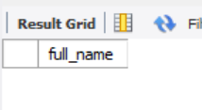
CREATE DATABASE Exercise2_ADDRESSBOOK;
USE Exercise2_ADDRESSBOOK;
CREATE TABLE employee_data (
employee_id INT AUTO_INCREMENT PRIMARY KEY,
f_name VARCHAR(100),
l_name VARCHAR(100),
title VARCHAR(100),
age INT,
yearsofservice INT,
salary DECIMAL(10,2),
perks DECIMAL(10,2),
email VARCHAR(100)
);
INSERT INTO employee_data (f_name, l_name, title, age, yearsofservice, salary, perks, email) VALUES
('John', 'Manalo', 'Web Designer', 29, 3, 72000, 3500, 'aaron.lopez@bignet.com'),
('Recelle', 'Janda', 'Marketing Staff', 32, 4, 88000, 6000, 'bianca.santos@bignet.com'),
('Kristina', 'Muloy', 'Data Analyst', 30, 2, 76000, 4500, 'celine.torres@bignet.com'),
('Falia', 'Castillo', 'Project Manager', 41, 10, 110000, 16000, 'darren.castillo@bignet.com'),
('Sheryl', 'Toledo', 'Programmer', 27, 3, 83000, 9000, 'elaine.mendoza@bignet.com'),
('Kishe', 'Gacute', 'Sales Associate', 38, 7, 115000, 19000, 'francis.diaz@bignet.com'),
('Raicelyn', 'Salas', 'Programmer', 35, 9, 125000, 20000, 'gwen.reyes@bignet.com'),
('Hannah', 'Paz', 'HR Assistant', 26, 1, 58000, 3000, 'hannah.lim@bignet.com'),
('Maristine', 'Marquez', 'IT Support', 31, 3, 67000, 3200, 'ivan.ramirez@bignet.com'),
('Jaren', 'Quezon', 'Web Designer', 28, 2, 69000, 2800, 'jared.flores@bignet.com');
SELECT employee_id FROM employee_data WHERE age > 30;
SELECT f_name, l_name FROM employee_data WHERE title = 'Web Designer';
SELECT * FROM employee_data WHERE salary <= 1000000;
SELECT salary, perks FROM employee_data WHERE perks > 16000;
SELECT CONCAT(l_name, ', ', f_name) AS full_name FROM employee_data WHERE title = 'Marketing Executive';

